Business and Technical Requirements Specification

This document outlines the business and technical requirements that your team must design and build.

SECTION 1: Business Requirements

This section outlines the “Business Requirements” that will need to be met by the solution.

REQ 1: Gain insight into customer sales and loyalty (REQUIRED)

We want to be able to see key metrics relating to our customers' lifetime value. Specifically we need the following metrics for each customer:
  - Total Lifetime sales count ( total number of orders )
  - Total lifetime revenue ( Total amount of orders)
  - Total lifetime Profit (order amount - cost of goods sold)
  - First Order Date
  - Days since last order
  - Lifetime average order value ( based on total order amount)
  - Number of Trucks visited
  - Customer Value Tier ( based on life time revenue ) based on the following tiers
    - $0-$500 : Tier 4
    - $500-$2000 : Tier 3
    - $2000 - $3000 : Tier 2
    - $3000 : Tier 1

When want a single table or view that contains customer details and their metrics

SUCCESS CRITERIA: You must answer the following questions:
- What is the count of customers in each “Customer value Tier”?
- What is the average order value of customers in each “Customer value Teir”

TECHNICAL GUIDANCE:
- This will need to be a table or view in the consumption layer as it is designed to end user consumption
- As well as the metrics above you will also need to include details from the customer table including Name, city, country, gender, favourite_brand

REQ 2 : Gain insights in Truck sales (REQUIRED)

We need to understand the sales performance of our trucks . We need to understand things such as what kind of menu items are popular at each truck and the profitability of each truck over time. We need to analyse truck performance by truck location (city, country) and also by Franchise ( where the truck is managed by a franchisee)

SUCCESS CRITERIA:
- What is the gross profit margin percentage for each truck brand in 2022?
- What is the average total sales gross profit for a Corporate owned truck vs a Franchise owned truck in 2022?

TECHNICAL GUIDANCE:
- We do not get profitability data in the RAW layer. We want to calculate and store derived values such as gross profit in the transformed layer as they will be used in various CONSUMPTION layer tables/views. Unit Cost data can be found in the Menu table.
- We want gross profit data at the order detail level and the order header level.

REQ 3: Gain Insights into Areas for Improvement (REQUIRED)

We need to understand areas for improvement from customer reviews. We need to classify and record if the review indicates 1 or more of the following types of issue:
- operational issue
- food quality issue
- service issue.

We also want to experiment if we could identify when a customer leaves a bad review and then selectively send them an apology message along with a discount. To do this we need to get the review data into the CONSUMPTION layer within 15 minutes of new data landing in the data platform.

SUCCESS CRITERIA : The following criteria should be met.
- What are the TOP 5 Truck Brand Names that have the MOST areas for improvement. “Most areas for improvement “ can be calculated by counting the number of reviews that indicate there is an operational issue or a service issue or a food quality issue. We want to be able to produce something that looks like this:
Truck Brand Name | Count of Review with operational issues | Count of Reviews with Food quality issues | Count of Reviews with service issues | Count of all issues
Brand A | 22 | 23 | 1
Brand B | 12 | 32 | 17

- Prove that we can get data from the RAW table to the CONSUMPTION table in 10 minutes

TECHNICAL GUIDANCE:
- The menu data will require some transformation to occur between the RAW and TRANSFORM layers
- Look into the AI_COMPLETE() function to see how you might determine if the review text indicates operational, food, and/or service issues.
- IMPORTANT NOTE: There are 1000 reviews in the review table so while developing your code that uses AI functions make sure you work with a small set of reviews to conserve credits / tokens
- The Truck review table in the TRANSFORMED schema will need to have additional columns (e.g. operational issue, service issue, food quality issue) to store a flag .
- Investigate if Dynamic Tables could help get the data from the RAW layer through to a table in the CONSUMPTION layer in less than 15 minutes

REQ 4: Gain insights into Tasty Byte menu (REQUIRED)

We need to be able to create queries and dashboards that are focused on menu performance. We want to be able to answer questions such as :
- What are the most popular menu items ( measured by order count) in each city, country, and truck over time.
- What's the sales performance of menu items in both total revenue and gross profit by city , country truck

SUCCESS CRITERIA: You must answer the following questions:
- What are the top 5 menu items by sales volume (i.e quantity sold) in the 1st Quarter of Financial Year 2023
- Determine total sales, total cost of goods sold, and total net sales ( total sales - total cost of goods sold) by menu item category ( excluding Beverage category) for Gluten free menu items in Financial Year 2022
TECHNICAL GUIDANCE:
- Most financial reporting is done by financial year although sometimes we need calendar year so ideally sales data will be stored with calendar year AND financial year from the TRANSFORMED layer onwards.
- Tasty Bytes Financial Year is 1 July to 31 June. The Financial Year is the year in which the financial year ENDS. So a sale on 23/12/2025 would be financial year 2026.
- The business logic for determining financial year and quarter should be written once and called whenever we need to calculate and store
- You will need to transform the health metrics data between the RAW and TRANSFORM layers
- The MENU_ITEM_HELTH_METRICS_OBJ column in the RAW.MENU table contains the ingredient and health flags. This data will need to be extracted into columns as the RAW data is JSON.
- You will need to create a menu analysis view in the consumption layer that brings together the data you need to answer the questions in the SUCCESS CRITERIA section.

REQ 5: Ingest experimental IoT data (REQUIRED)

Tasty Bytes has deployed a pilot IoT product into 10 trucks. The sensors capture the Truck temperature and the Fridge temperature. We need to ingest the data into Snowflake so we can start analysing it.

SUCCESS CRITERIA:
- IoT data is made available in TRANSFORMED layer in a structured format so it can be queried by analysts
- Identify which of the trucks in the experiment have had the fridge temperature go over 4 degrees?

TECHNICAL GUIDANCE:
- A Snowpipe will need to be set up to ingest the data
- Some of the items you will need have already been set up in the RAW schema including
  - file format called json_iot_ff
  - Storage integration called tastybytes_iot_data which connects to an external s3 bucket.
- BEFORE you can continue, run the following query and give the results to the Snowflake team. They will need to update a policy on the AWS side for the integration to work.

DESC INTEGRATION tasybytes_iot_data ->>
select $1,$3
from $1 where $1 in ('STORAGE_AWS_IAM_USER_ARN','STORAGE_AWS_EXTERNAL_ID');


- You can then create the remaining items including
  - An external stage that uses the tasybytes_iot_data Storage Integration . NOTE the URL will be: s3://chind-snowpipe-484577546576-us-west2/
  - Files should be ingested into a RAW table in the raw format along with some useful metadata. RAW table needs the following columns:
    - Raw_id: auto incrementing number that acts as a unique id
    - Raw_payload : holds the JSON payload from the ingested message
    - Source_filename : available via file METADATA
    - Load_timestamp : timestamp from when the file was loaded into the table.
  - A snowpipe to do the ingestion. Your snowpipe definition will need to:
    - point the following SNS TOPIC ARN: arn:aws:sns:us-west-2:484577546576:chind_snowpipe_data_gen
    - Copy data into the RAW table.
    - NOTE: It may take a few minutes for your pipe to activate. Check the SYSTEM$PIPE_STATUS function or check in Snowsight
    - You may also have to manually refresh the PIPE to load the historical data.
- The JSON message looks like this. There is one message per file

{
"truck_id": 1,
"truck_temp_in_c": 52.42,
"fridge_temp_in_c": 7.96,
"message_id": "4690e553-3554-4657-a5f5-038c3fc349da",
"timestamp": "2025-12-14T02:04:07.008492+00:00"
}


- HINT: the whole process can be found here. This should give you an idea of what you might need to create to get the ingestion going https://docs.snowflake.com/en/user-guide/data-load-snowpipe-auto-s3

REQ 6: Security and Privacy (REQUIRED)

We have several security and privacy requirements that need to be met.

REQ 6.1 Sensitive data masking: PII data including Email, Phone Numbers and Birth dates need to be protected. The following rules must be implemented :
- Columns that contain email address, birthdates, or phone numbers must be masked when End users or data analysts query the data ( e.g. Users with the tb_data_end_user role or tb_data_analyst role)
- Data admin users can see unmasked data ( e.g. tb_data_admin )

SUCCESS CRITERIA:
- When you query a table containing any of the sensitive data fields as an end user ( tb_data_end_user role) or a data Analyst ( tb_data_analyst role) the data must be masked.
- When a user with the tb_admin role queries a table containing any of the sensitive data fields they can see the unmasked data.
- Masking Policies must be applied across all layers.

TECHNICAL GUIDANCE:

- We want to use TAG BASED MASKING POLICIES.
- Create the required TAG : tastybytes_PII_data in the GOVERNANCE schema
- Define required masking policies in the GOVERNANCE schema with the following business rules and apply the policies to the relevant tags so they apply across all 3 layers:
- Email: ********@domain.com - Anything before the @ symbol must be masked.
- Phone: *****1234 - Only the last 4 digits should be visible.
- Birthday: The day should default to 01. E.g. 23/11/1970 would become 01/11/1970

REQ 6.2 Row level Access :

Tasty Bytes has both corporate owned trucks and Franchise owned trucks. While most roles need to access sales data for both corporate and franchise trucks we have one business unit who should only see franchise truck sales data.

SUCCESS CRITERIA:
- When a data analyst from the Franchise team ( using the tb_data_analyst_franchise role) queries the order header or order detail tables in the TRANSFORMED layer they should only see order header and order detail data for trucks where the FRANCHISE_FLAG is 1

TECHNICAL GUIDANCE:
- Implement your row access policy in the TRANSFORMED layer
- Implement one or more Row Access Policies that check if the current role is the tb_data_analyst_franchise role and the FRANCHISE_FLAG in the truck table s 1
- The row access policy logic will need to check the truck table even though the policy is applied to the order header table.

REQ 7 : Data sharing (OPTIONAL)

We have strategic business partners (e.g Suppliers, marketing agencies etc) who we want to share certain data with. Initially we want to share the Truck Reviews and improvement data with a 3rd party organisation who is also a Snowflake user.

SUCCESS CRITERIA:
- Our partner can successfully access the truck review improvements data from their Snowflake account

TECHNICAL GUIDANCE:
- A data share will need to be created for the object(or objects) in the CONSUMPTION layer that you created to meet REQ 3 above.
- You need to share it with account ID: VNNCTQD.GNB15348

REQ 8: We want AI (OPTIONAL)

We saw a demonstration by Snowflake of something called Snowflake Intelligence where they could ask natural language questions against Snowflake data and get answers and insights. We think this would be really useful but want to see it working with our data.

SUCCESS CRITERIA: An end user can ask an AI chat bot the following questions:
- What was the total sales in 2022
- What menu item has been ordered the most.
- What are the top three Truck Brands by revenue in the last 5 years?
TECHNICAL GUIDANCE:
- Look into creating a semantic view over some of the TRANSFORMED or CONSUMPTION LAYER objects that you may need to answer the kinds of questions the business want to answer
- Then look into creating a Cortex Agent and then access that via Snowflake intelligence.

REQ 9: Publish Internal data products (OPTIONAL)

Data assets and data products are hard to find in our organisation. We want to make data products more discoverable to the wider business. Snowflake showed us something called internal marketplace which looked like it may address some of our pain points.

SUCCESS CRITERIA:
- An end user ( e.g. someone with the tb_data_end_user role) can search for and discover a data product for the Customer Metrics table/view created in REQ 1.
- They can get a good understanding of what the data product contains, who owns it/supports it, and how to use it.
- They can request access to the data product.

TECHNICAL GUIDANCE:

- Look into Snowflake Internal Marketplace listings.
- Additional permissions may need to be given to the tb_data_end_user role to access internal marketplace.

SECTION 2: Technical Requirements

TECH 1: Security (REQUIRED)

Access to Snowflake features and data must be managed with Role Based Access Control (RBAC). There needs to be 2 additional roles created :
- Tb_data_analyst
- tb_data_analyst_franchise
- Tb_data_end_user.

The RBAC rules are:

- End users ( tb_data_end_user) should only be able to access the CONSUMPTION layer. They should have READ ONLY access to all tables / views in this layer . Note there may be other permission you need to assign if you build some of the optional requirements,. ( e.g. Snowflake intelligence)
- Analysts(tb_data_analyst and tb_data_analyst_franchise) should be able to access TRANSFORMED and CONSUMPTION layers. Analysts should have READ ONLY access to all tables / views etc in these 2 layers.
- Data admin (tb_admin) will have access to all 3 layers. They will have full access to all layers and features ( e.g effectively SYSTEMADMIN) ( Note the tb_admin is granted during set up)

SUCCESS CRITERIA:
- When using the tb_end_user role the user should only be able to access the CONSUMPTION schema .
- They should only be able to SELECT from objects in the CONSUMPTION. They cannot insert or delete data or create or manage objects such as tables and views.
- When using the tb_data_analyst or tb_data_analyst_franchise roles the user should only be able to access the TRANSFORMED and CONSUMPTION layers.
- They should only be able to SELECT from objects in the TRANSFORMED and CONSUMPTION. They cannot insert or delete data or create or manage objects such as tables and views.

TECHNICAL GUIDANCE:
- Use an appropriate system role to create the new roles
- Grant the new roles the minimum access including future access to tables and views
- Grant the roles to the SYSADMIN role to maintain role hierarchy

TECH 2: Governance objects (REQUIRED)

All governance objects such as masking policies, row access policies and TAGS should be created in a GOVERNANCE schema.

SUCCESS CRITERIA :
- Governance schema exists and contains any governance items created

TECH 3: Tags (REQUIRED)

All tables and views need to adhere to our tagging policy.

TAG NAME | ALLOWED VALUES | APPLY TO | NOTES
DATA_DOMAIN | SALES  CUSTOMER  REFERENCE  PRODUCT | Tables  VIews  Dynamic Tables  Materialised Views | An object should be tagged with only 1 data domain.
ENV | NON_PROD  PROD | ALL OBJECTS | For the hackathon assume you are working in a NON_PROD environment

SUCCESS CRITERIA:
- All tables, views, dynamic tables, and materialised views across all 3 layers (RAW,TRANSFORMED,CONSUMPTION) have the required tags.

TECHNICAL GUIDANCE:
- None of the existing RAW tables appear to have tags so start there.
- Tag propagation may be useful but there may be conflicts.
- Tags are a “governance” object so should be stored in the GOVERNANCE schema

SECTION 3: HIGH LEVEL ARCHITECTURE

This section provides business and technical context for Tasty Bytes.

Tasty Bytes overview

The following provides an overview the the Tasty Bytes business.

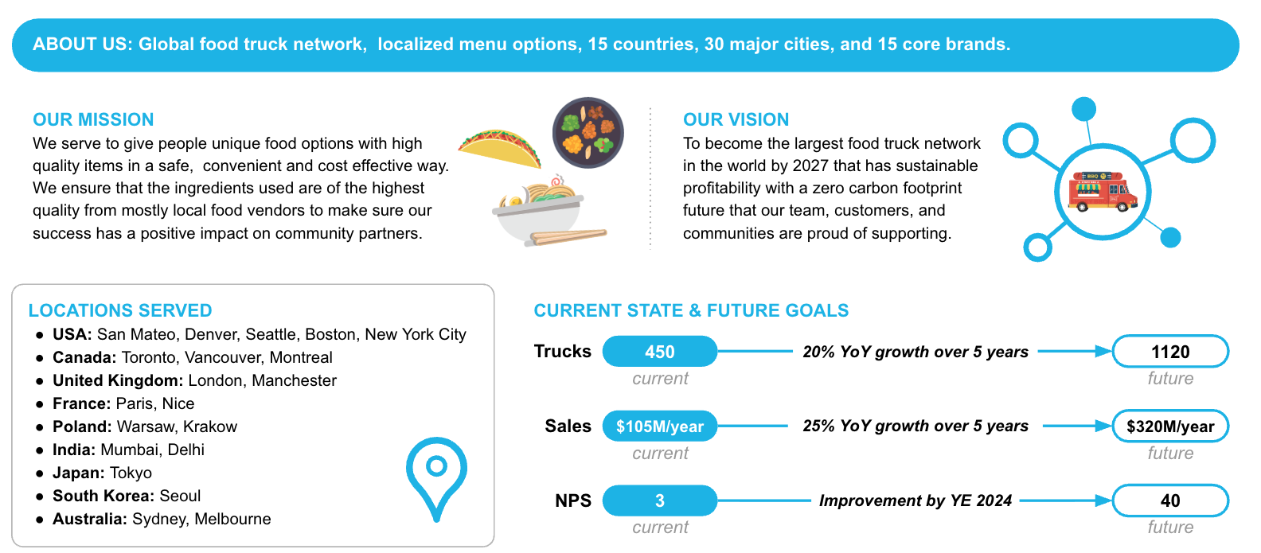

Current state data platform architecture

The following diagram provides a high level of the current state. The items shown are things that will be pre-created for you when you run the set up script

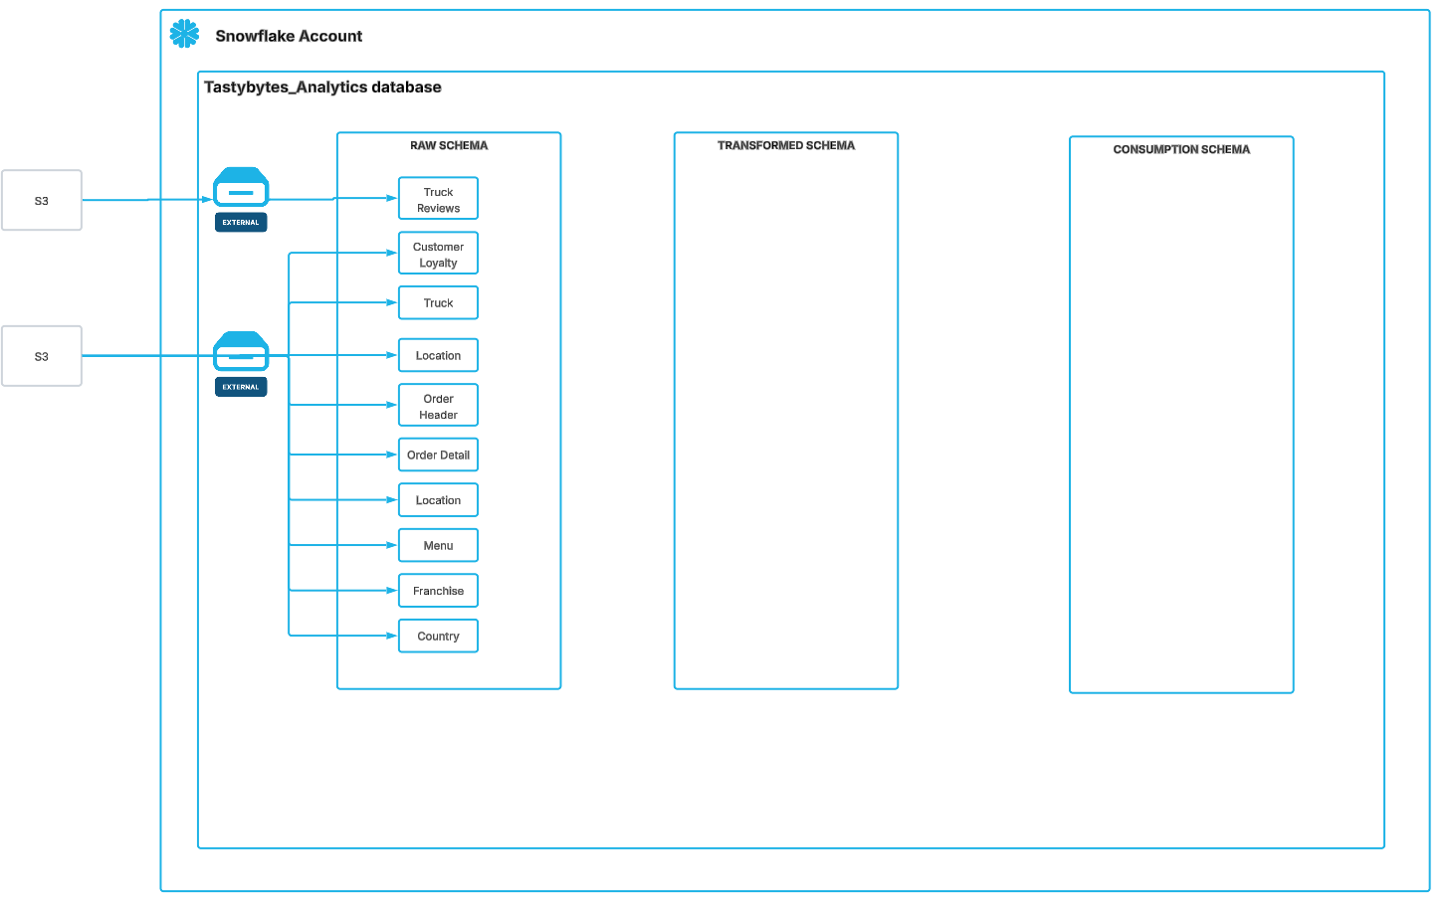

- You will use a database called TASTYBYTES_ANALYTICS
- The database will have 3 schema : RAW, TRANSFORMED, CONSUMPTION
- The RAW schema will contain a number of base tables. The set up script will create these tables and the data load script will populate them with data.

Tasty Business component view

The diagram below shows the core business component for Tasty Bytes which is truck sales.

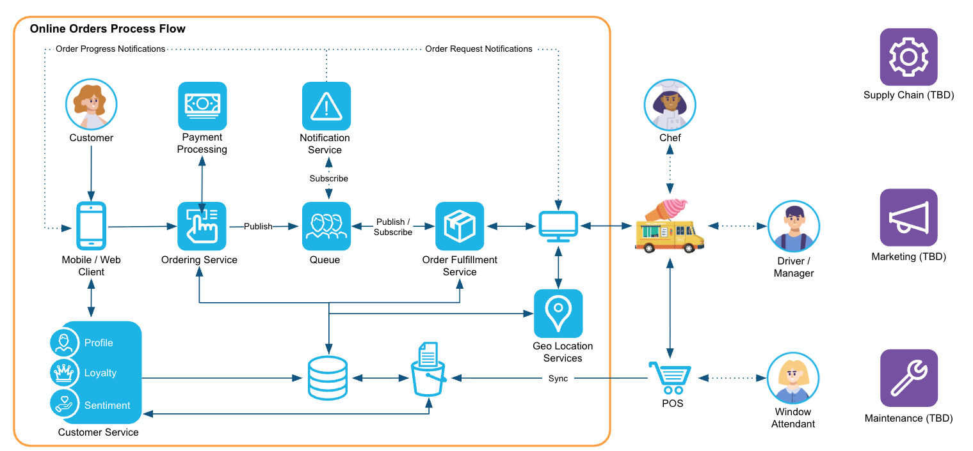

Tasty Bytes Data Model

The following is a high level data model for Tasty Bytes.

